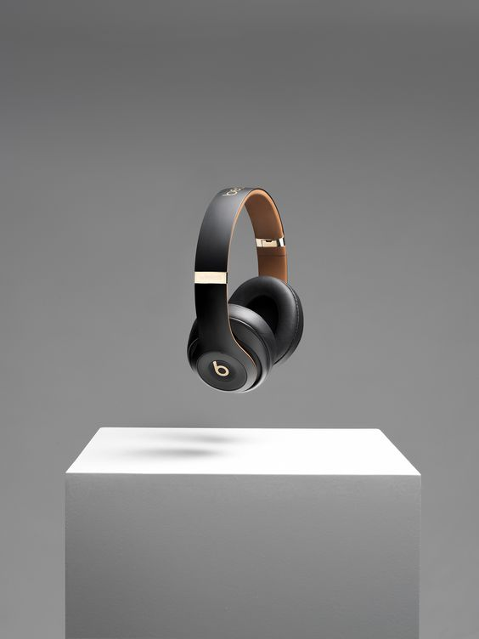

**SOUND**

SOUND

# PROJECT GROUP MEMBERS

|  |  |
| --- | --- |
| **Students ID** | **Students Name** |
| **Student1405891** | **M.SHEHRYAR SALEEM** |
| **Student1405839** | **ASAD SHAHID** |
| **Student1414752** | **ABDUL WASAY** |
| **Student1417806** | **SUREMA QADEER** |
| **Student1405282** | **GHOUSIA RASHID** |

|  |  |
| --- | --- |
| **CURRICULUM**  **7062** | **BATCH**  **2208E2** |
| **FACULTY**  **“MS. NEELAM MALIK”** | |
| **CO-ORDINATOR**  **“MS. WAJEEHA ASHFAQ”** | |

 SOUND

# DATABASE CONNECTION

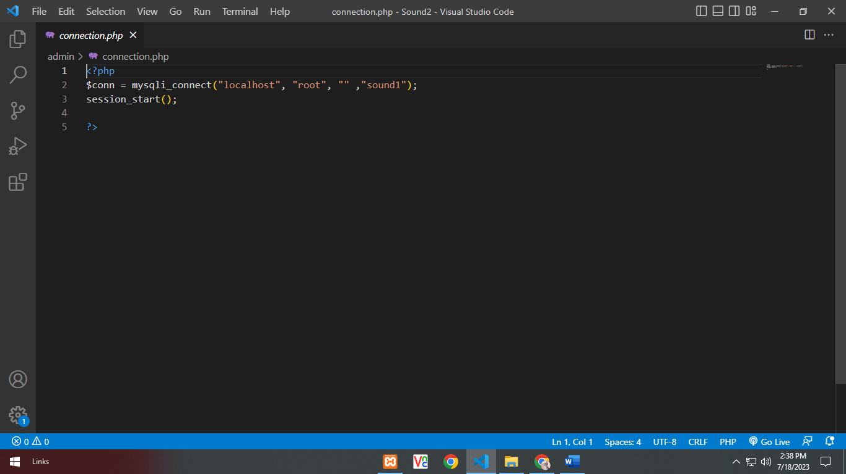



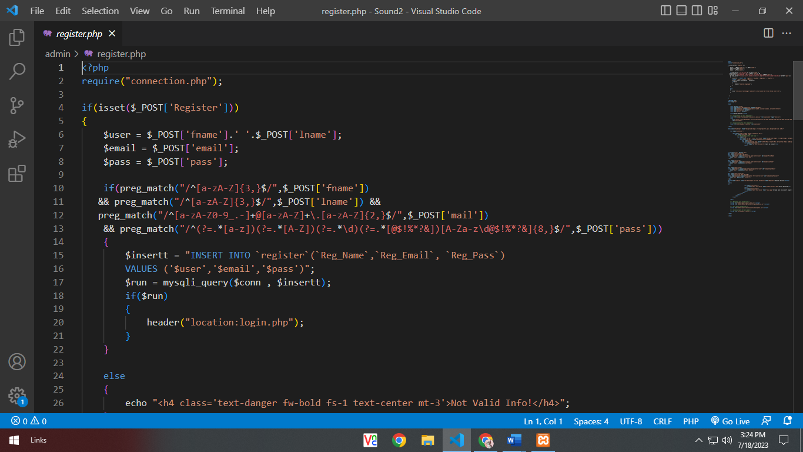**REGISTER**

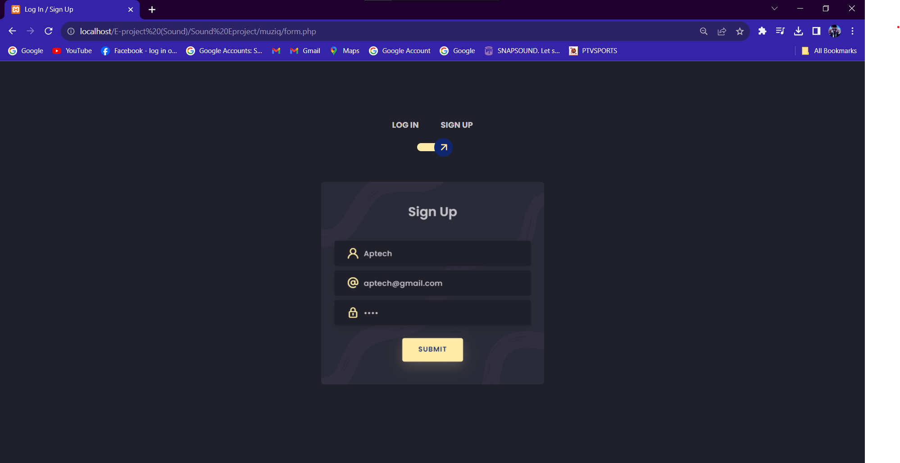

 SOUND

# LOG IN

# 

SOUND

# LOG OUT

SOUND

# VIDEO LIST

# 

SOUND

# GALLERY

# 

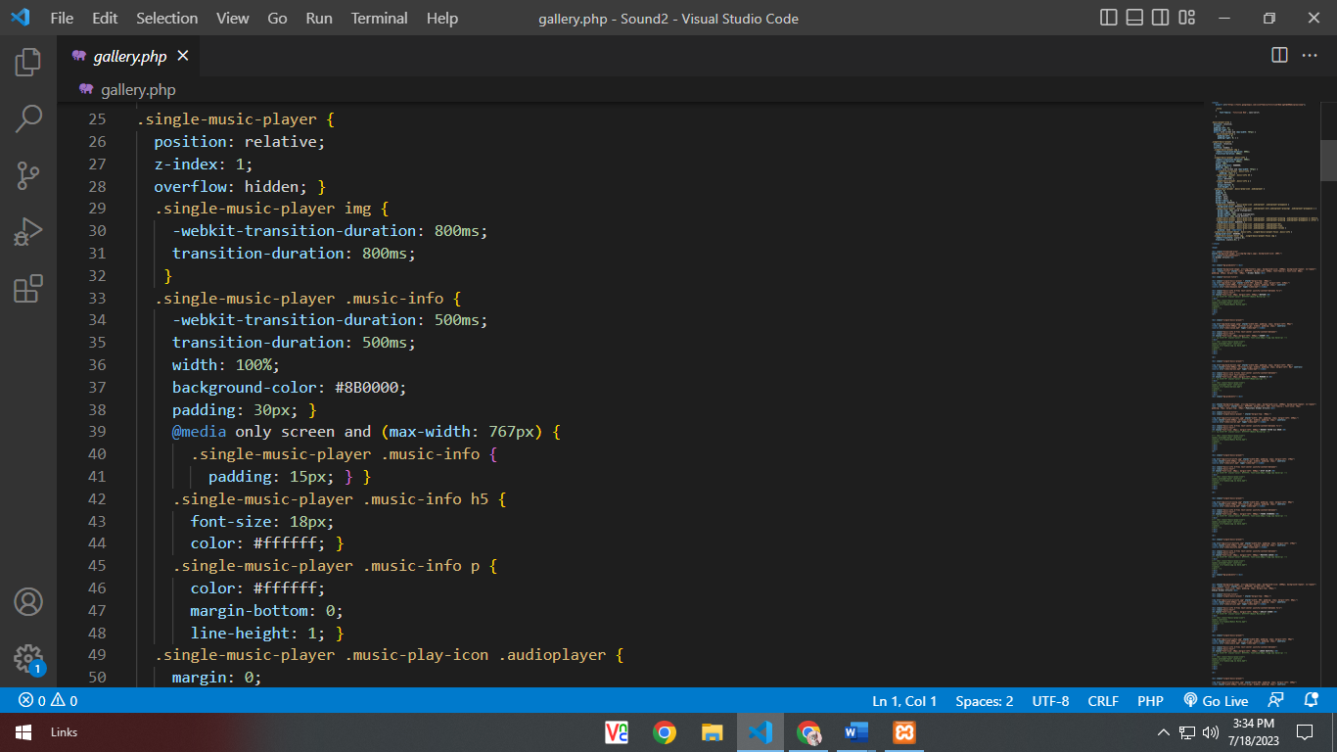SOUND

SOUND

**CONTACT US**

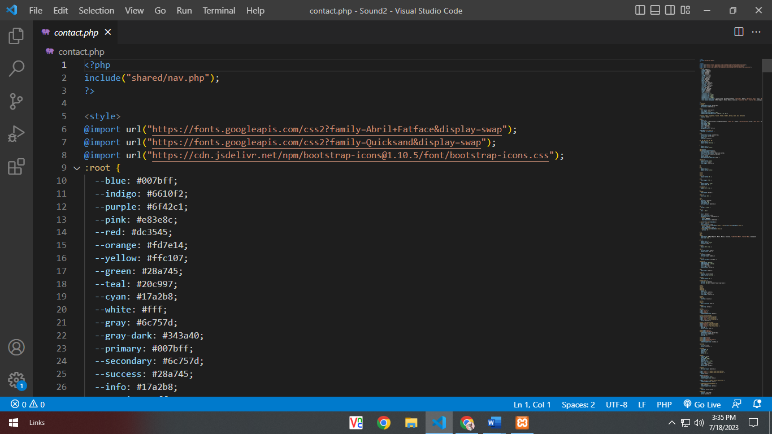

SOUND

# ABOUT US

# 